XIII LAW3M - Abstract Submission Template
Type your abstract title here
Please, use Title boldface, lowercase letters, do not capitalize words, 14 pt, centered

Author name(s), 12 pt, centered, boldface (the presenting author must be underlined)

Author affiliation(s) and full address, 12 pt, centered, italic.

The body of your abstract begins here. This MS Word file is the official template for abstracts (invited presentations, oral talks, and posters) to be submitted to the XIII Latin American Workshop on Magnetism, Magnetic Materials, & their Applications (XIII LAW3M). Please use this file to prepare your abstract and strictly follow the formatting instructions, as the abstracts will be directly reproduced in the conference proceedings distributed to the attendees. To prepare your abstract, replace the title, author names (the presenting author must be underlined), affiliations, and the abstract body text, keeping the original font type, size, and style of the template. The abstract body and references must be single-spaced, fully justified, and typed in Times New Roman, 12 pt, normal style. Neither indentations nor blank lines should appear between paragraphs in the abstract body. MS Word symbols and equations are allowed. One figure or one table may be directly inserted into the abstract file (see Figure 1). Figures (images or graphs in JPG or PNG format) must have a minimum resolution of 300 dpi. A caption must be placed below the figure or table. Up to three references are allowed per abstract. The abstract is limited to one page, including title, authors, affiliations, figures, tables, and references. Please submit the PDF version of the abstract electronically via the Conference System. No other file formats will be accepted. Abstract submission will be acknowledged automatically. Updates to submitted abstracts are allowed. Corresponding authors will be notified of acceptance or rejection by e-mail. Thank you for contributing to the XIII LAW3M, and we look forward to seeing you in Natal, October 19-23, 2026.
[1] C. Kittel, Rev. Mod. Phys. 21, 541 (1949).
[2] E. C. Stoner and E. P. Wohlfarth, Phil. Trans. R. Soc. Lond. A 240, 599 (1948).
[3] L. Néel et al., J. Appl. Phys. 31, 27S (1960).

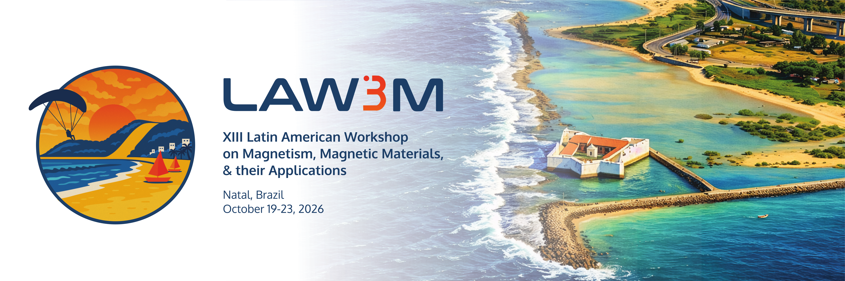
Figure 1: XIII Latin American Workshop on Magnetism, Magnetic Materials, & their Applications.

